Monitoring / On-Call Approval Form

Employee Name: Nikunj Adhaduk _

Manager Name: Vlad Rabenok .
Monitoring Hours
Date of Monitoring (mm/dd/yyyy) | Project | Reason | Number of Hours
Dec 2, 3 | Scene+ | Veracode devops pipeline created  Varacode scan | 6
Dec 13 | Scene+ | Website deployment and change for security | 1.5
TOTAL |  |  | 7.5

On-Call Payment
Dates On-Call (mm/dd/yyyy – mm/dd/yyyy) | # of Weeks | Rate
TOTAL
Approvals
Employee Signature:  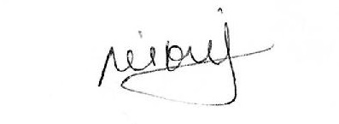 | Date:  14 Dec 2023
Manager Signature: | Date:  10 Nov 2023

Please submit to Payroll once approved.

